

American International University-Bangladesh (AIUB)  
**Department of Computer Science  
Faculty of Science &Technology (FST)  
Spring 20_21**

**Section: B**

**24 Hours Medical Assistance**

A software Engineering project submitted

By

|  |  |  |
| --- | --- | --- |
| Serial No. | Student Name | Student ID |
| 9 | ASHRAFUL HUDA RAFI | 19-39721-1 |

# PROBLEM DOMAIN

## Background to the Problem

The name of our project is 24 Hours Medical Assistance. It is a mobile application. This application is to give the right treatment at the right time without any delay, embarrassment, and harassment. The root cause of this problem is unorganized medical system. Very often, we don’t get the right treatment according to our problem in emergency condition. Best Doctors are not available all the time for consultation. In fact, financially everyone can’t afford the high fees of many doctors. Besides that, most of the common people are unknown about the doctors that are present in the hospital. They can’t understand which hospital is nearest and easiest to reach and get the proper treatment according to their health issue. This problem is the worst in our rural areas. They still remain far away from proper health treatment. They don’t even know the first aid of many diseases. Still, they are cheated by village quack. Instead of getting proper treatment they put their life in danger because of unawareness. They don’t understand where they should go and which hospital is near them, which treatment is the best. In fact, most of them don’t even know how to take appointment of the Doctor. They become the easy pray of broker for doctor’s appointment, for blood donation, for ambulance. This cheap broker demands a high amount for many of the simple tasks from innocent villagers. Many of them die due to not getting proper treatment at the right time for these reasons. Specially the pregnant women, during labor pain they suffers a lot to find a simple ambulance to reach the hospital at time. These problems are so important to consider because one minute delay to get the actual treatment can snatch one’s life. As example, if a person suddenly has a stroke and can’t reach the hospital due to transport problem, ambulance management, don’t get the right doctor he needs and ultimately don’t get proper treatment in time, he will die. So, this problem is so important to consider. Besides most of the people are unconscious about their mental health. This is very alarming. This unawareness can lead to permanent mental damage. Sometimes they don't feel necessary to consult with a doctor about their mental health. If someone is going through mental illness, they don't even like to talk about this to anyone for many social reasons and insecurities. This will increase their mental illness.

## Solution to the Problem

In this application, user can get help whether they register an account or not. But only some specific emergency services can be available without registration. This emergency services includes emergency ambulance service, nearby medical location, details of duty doctors. But one has to be registered to get benefits from other features of this software like for donation purposes (money, organ, blood), buying medical equipment and medicine, to get Doctors appointment and counselling schedule. This software will include all the possible medical related services in one platform. Through this they can manage all the basic needs during emergency. They can call ambulance as soon as possible by using location. Various vehicle agency will be connected to this software. They will be always preparing to provide ambulance service according to public demand. People also can find nearby hospital, doctor’s chamber & available doctors of the hospital by only mentioning their location and common health problem. They also can get appointment of doctor through this software, can get treatment through online counselling without going to chamber. There will be specific profile of a doctor of a specific hospital. By visiting their profile, they can get a overall get a view of the doctor like their degree, fees etc. There will be facilities for buying medical equipment like bandage, oximeter, diabetes machine etc. They can also buy medicine through the software and there will be delivery facilities. So, they don't need to go to dispensary. There will be a donation option. People can search for blood donation, organ donation and also money donation by visiting the option. So, they do not have to suffer for managing this during emergency and there will be no chance of being cheated by broker. There will be also article of famous doctor about health consciousness. By following this article and health tips people can live a sound health. This software will also be feasible to meet the business objective. When people will download this app from play store, play store will pay an amount of money to the authority of this software. As people have to resister for getting benefits through the software for every registration, the software authority will be paid. They can also get commission from the hospital authority, vehicle authority, medicine company. There will be also health related advertisement. App will be paid to allow this advertisement by the advertise company. So, the software can earn profit. As this software will connect all the possible benefits in one platform. The special features will attract people to use the software. The option of this software will be so specific and easy to understand. In fact, there will be language setup for using the app so that village people can use it by Bangla language and when a person open this software, there will be a tutorial about how to use this software. This software will also include various things in one app. The propose of this app is to provide emergency health service to common people as their need at right time. This specialty will be the main goal of the software. The benefits one can get from this are-

(i) transport facility

(ii) know about hospital location and its quality

(iii) get online appointment

(iv) find doctor according to their need

(v) buying medicine and medical equipment through online

(vi) donation facility (blood, money, organ)

(vii) online counselling for their problem

(viii) question answer section

The objective of the software is to provide service to common people to avoid various uncertain problem that they face to meet up with health problems and develop a relation between doctor and patient and also earn profit through the software.

The goal of the software is to connect most of common people with it by providing satisfied emergency health services and get profit through this.

# SOFTWARE DEVELOPMENT LIFE CYCLE

## Process Model

After analyzing the software's nature and environment (24-hour medical assistant), we will develop, and the method has chosen a scrum process model. Scrum is a method of software development, all the features of the software proposed here are initially divided into small parts. The whole period of growth is divided into small parts between one week to one month, each component is called a sprint. A small team works to perform specific tasks on each sprint. Each day, the group holds 10-15 minutes daily meetings to update each other's work. At the end of each sprint, the work result is expected, i.e., some part of the software has been completed, which can be provided to the client to check if the work is being done correctly. Also, it has been reviewed so that some work on the sprint has been done correctly, and what has not been done will not be a problem. In this way, the whole software is created by completing one sprint after another.

Scrum model:

1. It is possible to keep pace with changes in software development,

2. Everyone equally knows who is doing what and how the Team maintains transparency.

3. In Scrum, it is possible to calculate how much time is spent on each part of the work before starting work; each sprint is more effective considering the previous sprint experience.

4. One of the features of proper accountability scrutiny is that everyone is updating them

after work every day. There is the transparency of accountability as there is immediate

transparency.

5. The risk is much lower in this method. Every day there is a problem being checked, and action is being taken accordingly. Also, if a sprint's work fails in any way, it will not affect the whole development. As a result, it is possible to supply quality products. This method makes it possible to develop software in a relatively short time, resulting in lower costs.

Initially, analysis, design, coding, testing, and distribution are given in the waterfall model.

The problem with this is that all the work must be done at one stage. It is not possible to change the demand in the middle of development. Once the whole process is over, the client will get the product.

Many clients may not feel well, then starting the development process again is subject to extra cost and time. The only reason such large software development projects fail.

The iteration method is a lot like the Scrum method, but at the end of each sprint, another sprint's work starts, i.e., some part of the software is completed, which cannot be provided to the client due to which the work cannot be adequately verified.

## Project Role Identification and Responsibilities

There is the role in the project management activities in software development.

1. Scrum Master
2. Product Owner
3. Scrum Team
4. Customer
5. Management

* Description the responsibilities of the role in the software development.

1. Scrum Master:

The scrum master is the team role responsible for ensuring the team lives agile values and principles and follows the process and practices that the team agreed they would use. The Scrum Master's responsibilities to the Product Owner include, finding techniques to manage the backlog. Helping the scrum team to understand the need for a clear and concise backlog. Ensuring the product owner knows how to prioritize the backlog to get maximum value. And facilitating scrum events. The Scrum Master's duties to the development team include coaching the team to self-organize. Removing development roadblocks. And facilitating scrum events (Sprint Planning, Daily Scrum, Sprint Review, and Sprint Retrospective).

1. Product Owner:

The product owner is a member of agile team responsible for defining stories and priorities the team backlog to streamline the execution of the program priorities while maintaining the conceptual and technical integrity of the features or components for the team product owner. Product Owner (PO) is officially responsible for the project, managing, controlling, and making visible the Product Backlog list. Product owner is responsible for defining and prioritizing requirements for the product backlog.

1. Scrum Team:

A Scrum team needs three specific roles: product owner, scrum master and the development team. And because scrum teams are cross functional, the development team includes testers, designer, and ops engineers in addition to developers. Scrum teams are cross-functional, highly efficient, and self-organized teams that collaborate to produce high-quality product increments, according to the Scrum concept.

1. Customer:

Customer participates in the tasks related to product Backlog items for the system being developed or enhanced.

1. Management:

Managers describe the products or projects that teams can work on in Scrum. Managers set a simple aspirational goal. Scrum teams have a purpose and direction thanks to the goals set by managers. Teams are created by managers.

# PRODUCT AND PROJECT DESCRIPTION

## System Features

**1. Software Login**

**1.1** Already described in exercise-3 example.

**2. Background Color**

**2.1** System by default shows black background color to the user.

but it also allows user to choose their preferred color.

**2.3** After choosing the color, the user can also change it

**and does not** need to set it up every time because It will automatically be saved.

**Priority level:**Low.

**Precondition:**Users need to login into the account first.

**Cross-references:**  N/A

**3. Language**

**3.1** System will automatically set the language to English

but also allow the user to choose their preferred language.

**3.3** After choosing the language, the user can change it. anytime

**and does not** need to set it up every time because It will automatically be saved.

**Priority level:**Low.

**Precondition:**Users need to login into the account first.

**Cross-references:** N/A

**4.Emergency Ambulance Service**

**4.1** User location will be tracked by the system.

**4.2** which will enable our emergency ambulance system to respond at any time with swift speed

**4.3** system will also show the location and arrival time of our ambulance

**Priority level:**High

**Precondition:**Users need to login into the account first.

**Cross-references:** N/A

5.**Hospital location and its quality**

**5.1** Emergency or general time will be selected according to the quality of the reviews given by the users including the location near the hospital.

**5.2** Higher rate will be first priority, but higher rates inability will cause the system to lower the rate choose from there

**Priority level:**Medium

**Precondition:**Users need to login into the account first.

**Cross-references:** N/A

**6**.**Online/Offline appointment with Doctor’s profile**

**6.1** users will have the choice to select from a wide range of specialist

**6.2** users will also have access to all the general information of the doctor they select

**6.3** users will also have the option of offline and online care service

**Priority level:**High

**Precondition:**Users need to login into the account first.

**Cross-references:** N/A

**7.Online council**

**7.1** users will have a service to contact a psychiatrist for their mental care

**Priority level:**High

**Precondition:**Users need to login into the account first.

**Cross-references:** 6

**8.Primary aid**

**8.1** our site also provides with the option of first aid and primary medical knowledge for general purpose.

**Priority level:**Medium

**Precondition:**Users need to login into the account first.

**Cross-references:** N/A

**9. Payment**

**9.1** users have both online and offline payment option

**9.2** users for online can do it from our site directly

**9.3** users for offline have to pay it to the physician in person

**Priority level:** High.

**Precondition:** User must have a valid ID and password

**Cross-references: 10**

**10.Medicine & Medical Equipment buy**

**10.1** users will have the option to buy medicine and medical equipment (pressure machine, blood sugar machine) from our site with a special discount

**Priority level:**Medium.

**Precondition:**Users need to login into the account first.

**Cross-references: 9**

**11.Medicine Remainder**

11.1 our system provides with automated reminder option for medicine intake

**Priority level:**High.

**Precondition:**Users need to login into the account first.

**Cross-references:** N/A

**12.Donation**

**12.1** here users can be a doner.

**12.2** users also will have an interface where they can register themself for organ, blood and money donation.

**Priority level:**High.

**Precondition:**Users need to login into the account first.

**Cross-references:** N/A

**13.Contact Us**

**13.1** user will have the ability to contact the administration at anytime

**Priority level:**Low.

**Precondition:**Users need to login into the account first.

**Cross-references:**  N/A

**14. FAQ**

**14.1** There will be a question-and-answer section for the users any query

**Priority level:** Medium.

**Precondition:** Users need to login into the account first.

**Cross-references:** N/A.

**15.Update**

**15.1** The app will get a regular system update and an occasional maintenance

**Priority level:** Medium.

**Precondition:** User must have a valid ID and password

**Cross-references:** N/A.

**16. Settings & Privacy**

**16.1** users can update their name, phone number, email addresses. at any given time

**16.2** Users have the option to delete or deactivate their account.at any time

**16.3** Users personal information and location will be hidden from other users.

**Priority level:** Medium.

**Precondition:** User must have a valid ID and password

**Cross-references:** N/A

**17.** **Account Security**

**17.1** Users can change their password any time they want

**17.2** Users will have the option to enable two-factor authentication. and get alerts about unrecognized login.

**Priority level:** Medium.

**Precondition:** User must have a valid ID and password

**Cross-references:** N/A

**18. Terms and Conditions**

**18.1** In order to use this software, users must abide by certain terms and conditions which have been explained here.

**Priority level:** Low.

**Precondition:** Users need to login into the account first.

**Cross-references:** N/A.

**19.Feedback**

**19.1** Users can select a feedback tab in which a page with a comment box shows up.

where they can leave any feedback, they think will help us improve their experience with our app

**Priority level:** Low.

**Precondition:** Users need to login into the account first.

**Cross-references:** N/A.

**20. Report**

**20.1** Users will have the ability to report here any unpleasant incidents that have happened to them.

**Priority level:** Low.

**Precondition:** Users need to login into the account first.

**Cross-references:** N/A.

## System Quality Attributes

**Availability:** Availability is more important for any website or any global application. Our system will be available almost all the time. The system shall be at least 96 percent available on weekdays between 6:00 a.m. and midnight local time, and at least 99 percent available on weekdays between 8:00 a.m. and 10:00 p.m. local time. Every user will be able to take any facilities from this system.

**Performance**: Performance requirements define how well or how rapidly the system must perform specific functions. Speed, throughput, capacity, timing. Performance requirements should also address how the system's performance will degrade in an overloaded situation.

**Efficiency:**It deals with the hardware resources needed to perform the different functions of the software system. It includes processing capabilities, storage capacity, and data communication capability. It also deals with the response time between recharging of the system’s portable units, such as information system units located in portable computers, or meteorological units placed outdoors.

**Flexibility**: This factor deals with the capabilities and efforts required to support adaptive maintenance activities of the software. These include adapting the current software to additional circumstances and customers without changing the software. This factor’s requirements also support perfective maintenance activities, such as changes and additions to the software in order to improve its service and to adapt it to changes in the firm’s technical or commercial environment.

**Integrity**: Integrity this factor deals with the software system security, that is, to prevent access to unauthorized persons, also to distinguish between the groups of people to be given read as well as write permit.

**Interoperability:** Interoperability requirements focus on creating interfaces with other software systems or with other equipment firmware. For example, the firmware of the production machinery and testing equipment interfaces with the production control software.

**Portability**: The ease with which a software system can be adapted to run on computers other than the one for which it was designed. A software system can be said to be portable if the effort required for porting it proves significantly less than the effort necessary for a new implementation.

**Reusability**: This factor deals with the use of software modules originally designed for one project in a new software project currently being developed. They may also enable future projects to make use of a given module or a group of modules of the currently developed software. The reuse of software is expected to save development resources, shorten the development period, and provide higher quality modules.

**Reliability:**Reliabilityof a software system is defined as the probability that this system fulfills a function determined by the specifications, for a specified number of input trials under specified input conditions in a specified time interval (assuming that hardware and input are free of errors). A software system can be seen as reliable if this test produces a low error rate

**Robustness:** Robustness reduces the impact of operational mistakes, erroneous input data, and hardware errors. í Robust software recovers gracefully from problem situations and is forgiving of user mistakes.

**Usability:** Usability requirements deal with the staff resources needed to train a new employee and to operate the software system. Also referred to as ease of use and human engineering, usability addresses many factors that constitute what users often describe as user-friendliness.

**Maintainability:** Maintainability work for debugging and for modification and extension of functionality. Maintainability depends on how easily the software can be understood, changed, and tested.

**Testability**: Suitability for allowing the programmer to follow program execution and for debugging. The testability of a software system depends on its modularity and structuredness. Modular, well-structured programs prove more suitable for systematic, stepwise testing than monolithic, unstructured programs. Testing tools and the possibility of formulating consistency conditions in the source code reduce the testing effort and provide important prerequisites for the extensive, systematic testing of all system components.

## Project Requirements

In this part, we give a description of system property, attribute, and how the system of project 24 Hours Medical Assistance should behave. this project has the capability of changing the way we use medical services. The time we are in right now it has made us realize how badly we need this kind of service. this service will be available for everyone on every corner for everyday use without any backlash of any kind. Our main purpose for this service is to make a service that will be reachable for anyone for any medical service with minimal cost and hassle and swift response.

**User:** The software is user-friendly, so the requirements contributed by users are the lead users.

**Features:** the app will have many features which have been approved by many beta users. Every feature has been carefully selected for the user’s perfect experience and easy use. Features will also be added by user’s request.

**Resources:** The amount of money that’s available for achieving the desired outcome will be restricted to the use and acquisition of resources. If the resource is essential to the project, we’ll have to sacrifice some things because no reasonable amount of money could reduce the delivery time.

**Budget:** This software is a start-up, so it needs funding from the stakeholders. But the budget will be determined by the amount of work that has been done and the amount that is needed to be done.

**Environment**: the environment of our app depends on the software tools. hardware and network

Resources. Meaning that its environment can change depending on the things that have been used but the basic environment will always same.

# SYSTEM DESIGN SPECIFICATION

**Use Case diagram :** In the user scenario of our system the major data features are Emergency Ambulance, Create Account, Login, Doctor Appointment, Primary Aid, Medicine Buy, payment, Donation, Hospital Location, Contact, Medicine Remainder.

Firstly, user access to this system. In emergency case, user can enter Emergency Ambulance service. Without user account, the user will only get the ambulance service. If user has no account then he can create an account and after login he will get many options which will be very helpful for him. After Login, he will be able to take primary aid, doctor appoinment( doctor profile, schedule, service fee),medicine buy, medicine remainder, hospital and doctor contact number. Therefore, he will also be able to pay for various service fee (Bkash,Rocket,Card) with it. User know the hospital location and destination with it. Finally, the user will be able to ask a question in the question answer section and the doctor will be able to give feedback.

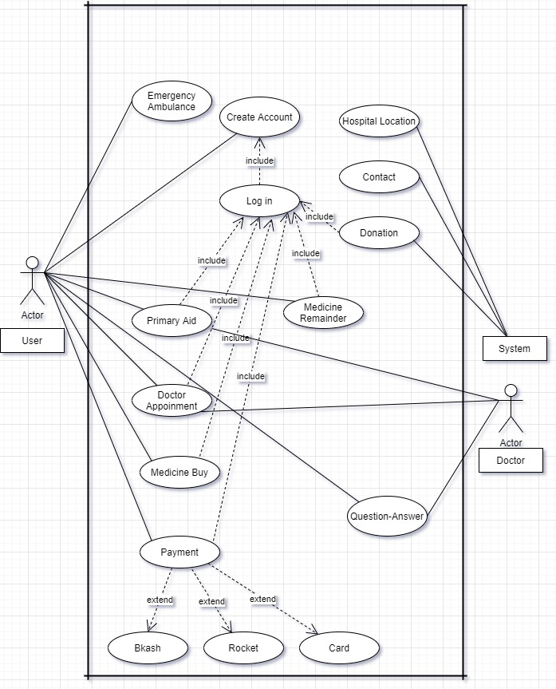

**Activity Diagram:**

In the user scenario of our system the major data features are Emergency Ambulance, Create Account, Login, Doctor Appointment, Primary Aid, Medicine Buy, payment, Donation, Hospital Location, Contact, Medicine Remainder. In emergency case, user enter this app and he will be able to take advantage of emergency ambulance service, emergency hospital and ambulance contact number and also identify the hospital location. After creating an account or login, he will get many advantages of many functions like primary aid, doctor appointment, medicine buy, medicine remainder. The user wants to see the doctor’s profile, time scheduling and their service fee. In case of doctor appointment, if the user wants, he can meet doctor with online or offline. In the donation sector, user will able to donate blood, money, organ and also any emergency issues, user will able to know the information’s of blood, money, organ if is it available or not. The user will be able to know the time of his medicine by setting the medicine reminder. User also ask question to doctor and doctor will able to deliver their feedback.

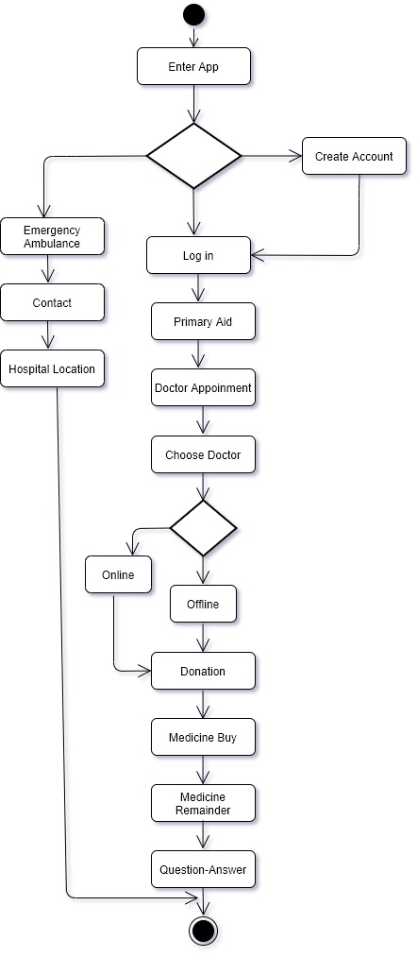

**Class diagram:**

In our system class diagram scenario is very important. In our system there are four class for this class diagram and there are also ten sub class for this class diagram. Here, user class is connected with registration class and emergency service class. Between user class and registration class there is one to one relation. On the other hand, between user class and emergency service class there is also one to one relation. In the emergency service class has two sub class also such as volunteers and ambulance.

So that, the relation between emergency service class and volunteers is one to many because emergency service can be one, but volunteers can be many. There is also a relation between emergency service and ambulance this is also one to many relations because here emergency service can be one, but ambulance can be many. Secondly, there are also another class that is registered user so the relation between registration and registered user is many to many. Because anyone can registration and anyone can be registered user.

Thirdly, registered user has subclass medicine so there is many to many relations is exist. There is also a subclass donate and it relates to registered user by many to many relations. Here also subclass that is doctor’s information sub class and treatment subclass those relate to registered user by many to many relations. On the other hand, there is a subclass named is location so that the relation between registered user and location is many to many. In hospital, medicine shop and doctors chamber subclass has connected with location by many to many relations and location relates to registered user by many to many relations.

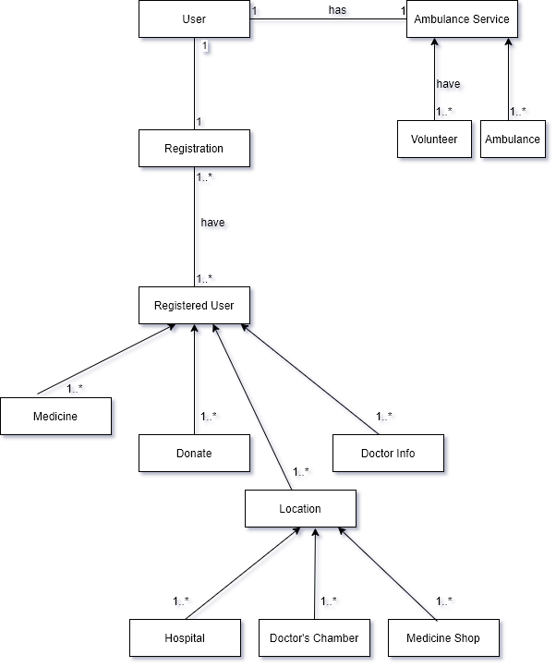

**Sequence Diagram:**

The user of the 24-hour medical assistance system will log in with the user ID, Password, until the user gives the correct ID, password and will not get the user interface, after logging in him, will be able to take the emergency ambulance service. He will be able to see the symptoms and treatment of some common problems, the User will be able to make an appointment with a doctor who will verify the system and if there is any problem, the admin will decline. He will be able to buy medicine, set an alarm for it while taking medicine. Users can make donations if they want, which will be verified by the admin, where they will decline in case of any problem. There will be a forum for general questions.

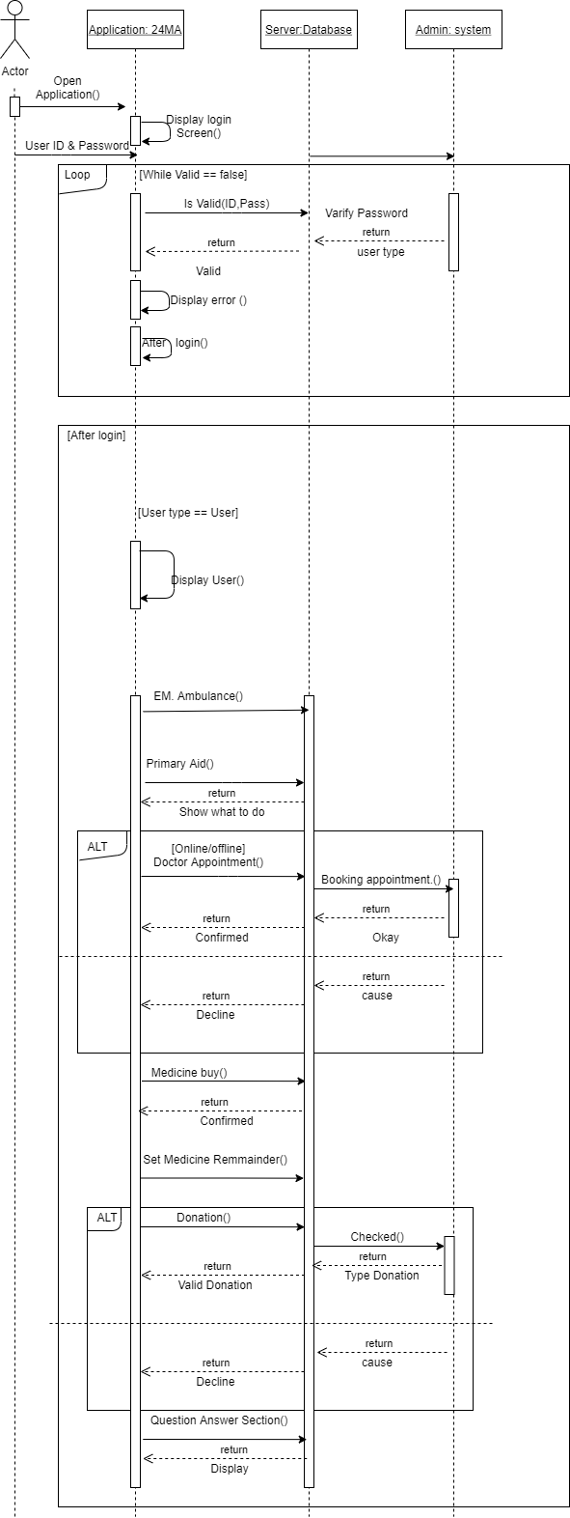

**E-R Diagram:**

 In the user scenario of our software the major data entities are login, payment, primary, medicine, dashboard, donation, appointment, doctor.

Yes, the data dictionary covers all the entities as mentioned in the ER diagram.

Does the ER diagram include the major data entities mentioned in the user scenario? Does the data dictionary cover all the entities as mentioned in the ER diagram?

Login: **username**, password

User: **name/id**, email, password, number

Primary Aid: common medicine

Doctor: **qualification**, email, number, name of doctors, schedule of doctors

Patient: **name**, number, address, email, medical report.

Medicine: name of medicine

Dashboard: facilities, question/answer section, doctors’ profile, schedule of doctor

Payment: bkash, nagad, sure cash, cash

Donation: blood, money, organs

Appointment: online appointment, offline appointment before checkup

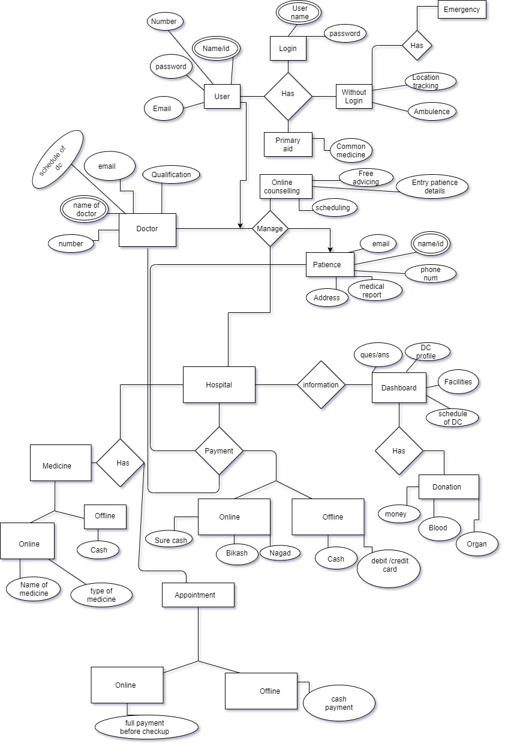

## UI/UX Design

# SYSTEM TEST PLAN

|  |  |  |  |  |  |
| --- | --- | --- | --- | --- | --- |
| Project Name:24 hours Medical Assistance | | | Test Designed by: Abdur Rahman | | |
| Test Case ID: FR_123456789 | | | Test Designed date:10-4-2021 | | |
| Test Priority (Low, Medium, High): High | | | Test Executed by: Deboraj Roy | | |
| Module Name: Emergency ambulance service | | | Test Execution date:11-4-2021 | | |
| Test Title: Verify the proper ambulance service and proper location tracking. | | | | | |
| Description: Test website emergency ambulance service page | | | | | |
| Precondition (If any): User must have 24 hours medical assistance app and GPS must be on. | | | | | |
| Test Steps | Test Data | Expected Results | | Actual Results | Status (Pass/Fail) |
| 1. Go to the apps. 2. Click Emergency Ambulance service. 3. User location will be tracked by the system. 4. System confirms it   and send ambulance at user location. | Location:  Uttara road- 12, sector -3 , DHAKA 1205 | Users get their ambulance at emergency time in a  short time. | |  |  |
| Post Condition: User is validated by location tracking. | | | | | |

|  |  |  |  |  |  |
| --- | --- | --- | --- | --- | --- |
| Project Name:24 hours Medical Assistance | | | Test Designed by: Ashraful Huda | | |
| Test Case ID: FR_13579 | | | Test Designed date:2-3-2021 | | |
| Test Priority (Low, Medium, High): High | | | Test Executed by: Mehjabin Mouly | | |
| Module Name:   Doctor Appointment | | | Test Execution date:4-3-2021 | | |
| Test Title: Verify the schedule of Doctors. | | | | | |
| Description: Test website for doctor Appointment page. | | | | | |
| Precondition (If any): User must have 24 hours medical assistance app and must login | | | | | |
| Test Steps | Test Data | Expected Results | | Actual Results | Status (Pass/Fail) |
| 1. Go to the apps. 2. Click Menu bar. 3. Click doctor appointment. 4. Checking schedule. 5. Click Online or offline. 6. If user wants to confirm appointment by online then payment will be before checkup / if user want to confirm appointment by offline then payment will be cash. | Username: Akib005  Password: 39909  Online:  Payment by Bikash, Nagod  Account.  Account number:0934882  Offline:  Payment by cash | Users get Doctors  Appointment by their choice. | |  |  |
| Post Condition: User can use more option otherwise user back from this page. | | | | | |

|  |  |  |  |  |  |
| --- | --- | --- | --- | --- | --- |
| Project Name:24 hours Medical Assistance | | | Test Designed by: Mehjabin Mouly | | |
| Test Case ID: FR_10975 | | | Test Designed date:10-4-2021 | | |
| Test Priority (Low, Medium, High): Medium | | | Test Executed by: Ashraful Huda | | |
| Module Name: Flexibility | | | Test Execution date:11-4-2021 | | |
| Test Title: Verify the flexibility process | | | | | |
| Description: Test the flexibility of website page | | | | | |
| Precondition (If any): No | | | | | |
| Test Steps | Test Data | Expected Results | | Actual Results | Status (Pass/Fail) |
| 1. Go to the software. 2. Check out the features are properly or not. 3. Capable to add new things. 4. If works properly then click ok. | Browser, checking feature, capabilities of add new things. | Software works properly by adding new feature. | |  |  |
| Post Condition: If testing is verified then it is ok to use. | | | | | |

|  |  |  |  |  |  |
| --- | --- | --- | --- | --- | --- |
| Project Name: 24 Hours Medical Assistance | | | Test Designed by: Deboraj Roy | | |
| Test Case ID: FR_103 | | | Test Designed date:12/04/2021 | | |
| Test Priority (Low, Medium, High): Medium | | | Test Executed by: Abdur Rahman | | |
| Module Name: Medicine Remainder | | | Test Execution date: | | |
| Test Title: Set medicine reminders for the patient | | | | | |
| Description: Set the alarm before it is time for the patient to take the medicine as per the doctor’s prescription. | | | | | |
| Precondition (If any): Users must be login by their valid account. | | | | | |
| Test Steps | Test Data | Expected Results | | Actual Result’s | Status (Pass/Fai) |
| 1. Go to the app. 2. Opens the “Remainder” option to set alarm. 3. The user will input the name of the medicine according to the doctor's prescription, how to take it, time, date. 4. Confirm to set reminder. | Name of medicine: Napa Extra  Today to next 7 day  Provide information: After taking food at 10:00pm. | The alarm will be set according to user input. | |  |  |
| Post Condition: Alarm will not be set without name of medicine, time and details of eating (operation will not be completed). | | | | | |

|  |  |  |  |  |  |
| --- | --- | --- | --- | --- | --- |
| Project Name: 24 Hours Medical Assistance | | | Test Designed by: Ashraful Huda | | |
| Test Case ID: FR_10001 | | | Test Designed date:14-04-21 | | |
| Test Priority (Low, Medium, High): High | | | Test Executed by: Abdur Rahman | | |
| Module Name: Performance | | | Test Execution date:14-04-21 | | |
| Test Title: Verify the system performance and speed | | | | | |
| Description: Check the system performance like speed, capacity, timing | | | | | |
| Precondition (If any): No | | | | | |
| Test Steps | Test Data | Expected Results | | Actual Results | Status (Pass/Fail) |
| 1. Go to the homepage. 2. Enter some feature. 3. Continue check feature one by one. 4. Check every feature response time, speed. 5. Check capacity in overloaded situation. | Overloaded situation its performance, capacity | Software work properly and efficient. | |  |  |
| Post Condition: No | | | | | |

# PROJECT MANAGEMENT PLAN

## Project Scheduling

* Identify all the micro tasks related to project management and categorize them within the WBS structure.
* Perform detailed effort estimation correspond with the WBS and schedule
* Draw a Gantt chart of the identified tasks from WBS based on the precedence of each task you’ve identified.

## Risk Analysis

* + Describe the available resources and their allocation in performing the project tasks
* Identify all the potential risks in your project development and provide a mitigation plan